The aim of this challenge is to find the total of all the visible numbers on the cubes.
We are using six cubes. Each cube has six faces of the same number.

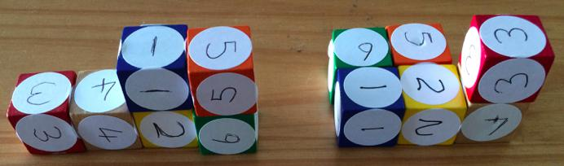
The shape we make has to be only one cube thick. The shape on the left is built correctly, but the shape on the right would not be allowed as it is two bricks thick in places.
The total of the shape on the left is 70. Can you see why?

CHALLENGE 1
Start by making a staircase shape. An example is shown below:
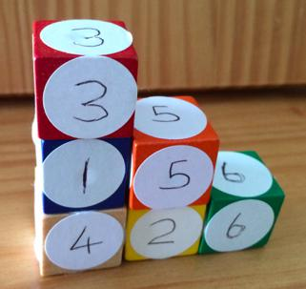

a) What is the highest total you can make by using this staircase shape?
b) What is the lowest total you can make by using this staircase shape?
c) How did you calculate the totals for a) and b) above? Why did you choose the method(s) that you did?
d) Have a go at making a total of 75 using a staircase shape.
CHALLENGE 2
Using any shape of single cube thickness, what is the lowest total you can make?
How can you be sure this is the lowest total whatever the shape?
Can the lowest total be found in more than one way? Justify your answer.

CHALLENGE 3

Using any shape of single cube thickness, what is the highest total you can make?
How can you be sure this is the highest total whatever the shape?
Can the highest total be found in more than one way? Justify your answer.
CHALLENGE 4

Prove the following by logical reasoning, rather than by calculating the answers:
If the cubes are arranged in a single vertical tower (like this)
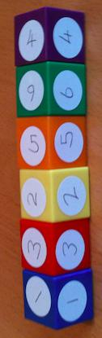
then no matter what order the cubes are in, the total cannot be 80.

